**Global Spice Symphony**

**CRC Workshop**

**on**

**Development and Deployment of Responsive Website**

Submitted To

**CRC-Training**

**By**

**Anjishnu Srivastava**

**Roll Number: 2402901520045**

**Aniket Dixit**

**Roll Number: 2402901540013**

**Under the guidance of**

**Mr. Vijay Kumar / Mr. Gaurav Kansal**

**CHAPTER 1**

**PROBLEM STATEMENT**

In today’s digital world, many local restaurants lack a well-organized and accessible online menu, which limits customer engagement and convenience.

This project addresses the problem by creating a responsive and visually appealing online restaurant menu using HTML, CSS and JavaScript.

The aim is to make the dining experience smoother for customers by helping them browse the menu items with ease. The design ensures that the menu is accessible from any device, including mobile phones.

It also helps the restaurant owners present their offers professionally. By doing this, we solve both visibility and usability issues common in traditional paper menus or outdated websites.

This project demonstrates practical web development skills applied to a real-world scenario.

**CHAPTER 2**

**IMPLEMENTATION AND RESULTS**

**Website =>** [**https://cosmicbeast.github.io/resturant-menu/**](https://cosmicbeast.github.io/resturant-menu/)

**index.html**

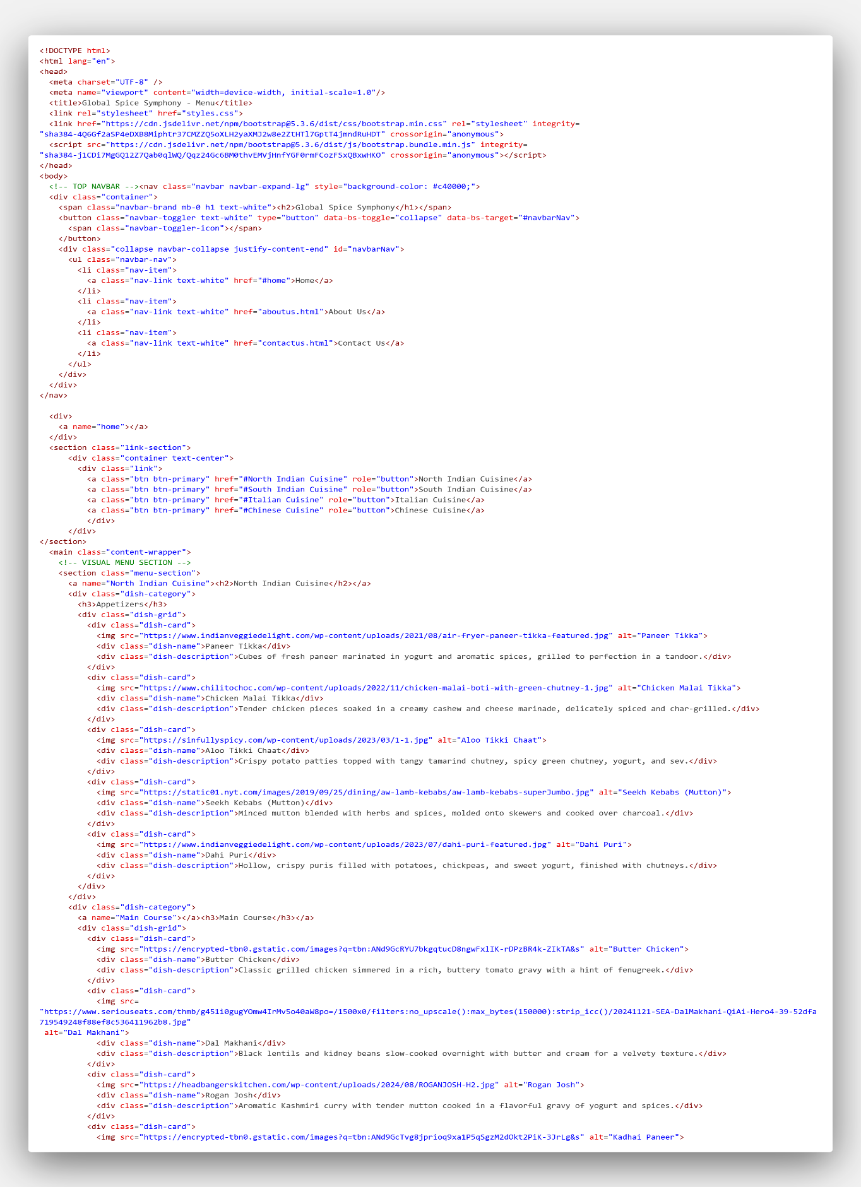

order.html

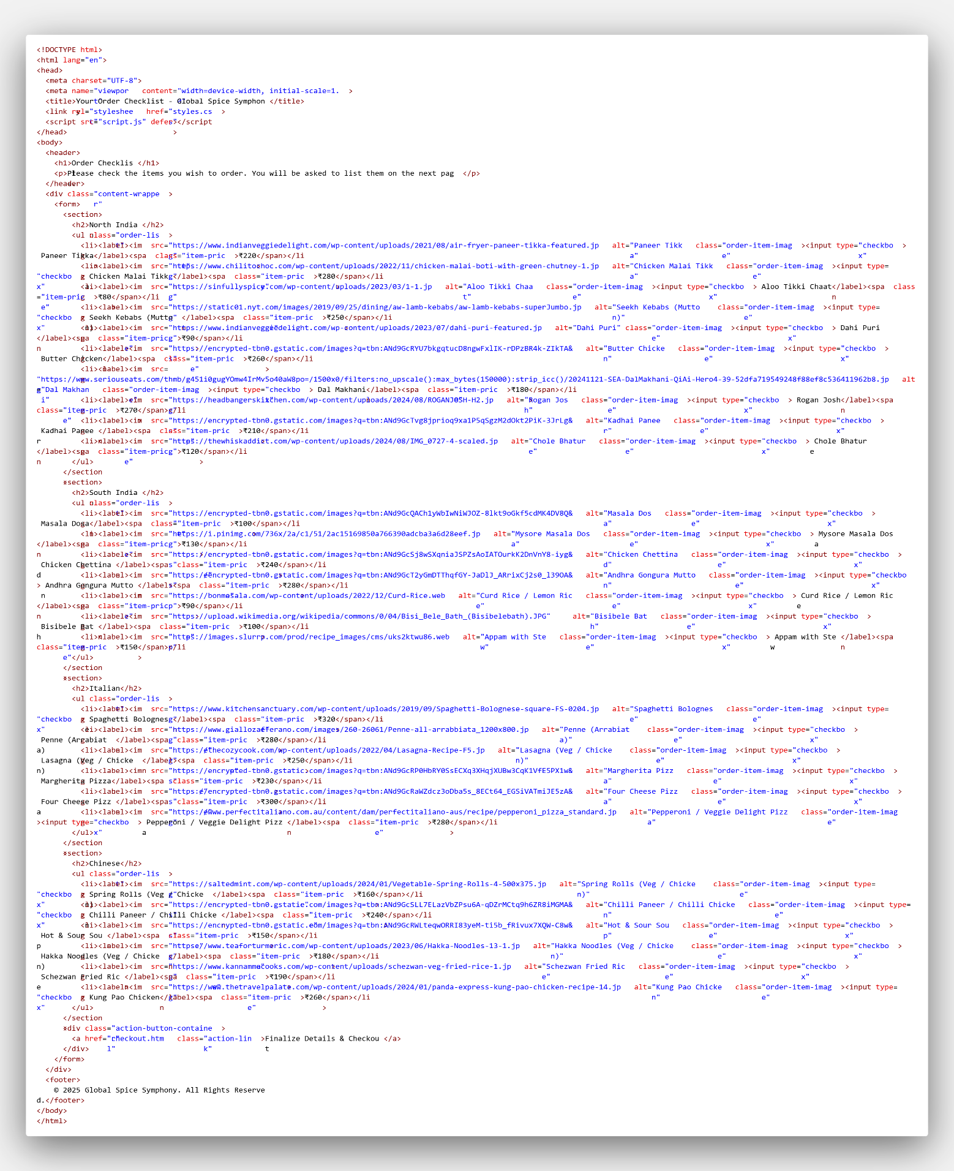

checkout.html

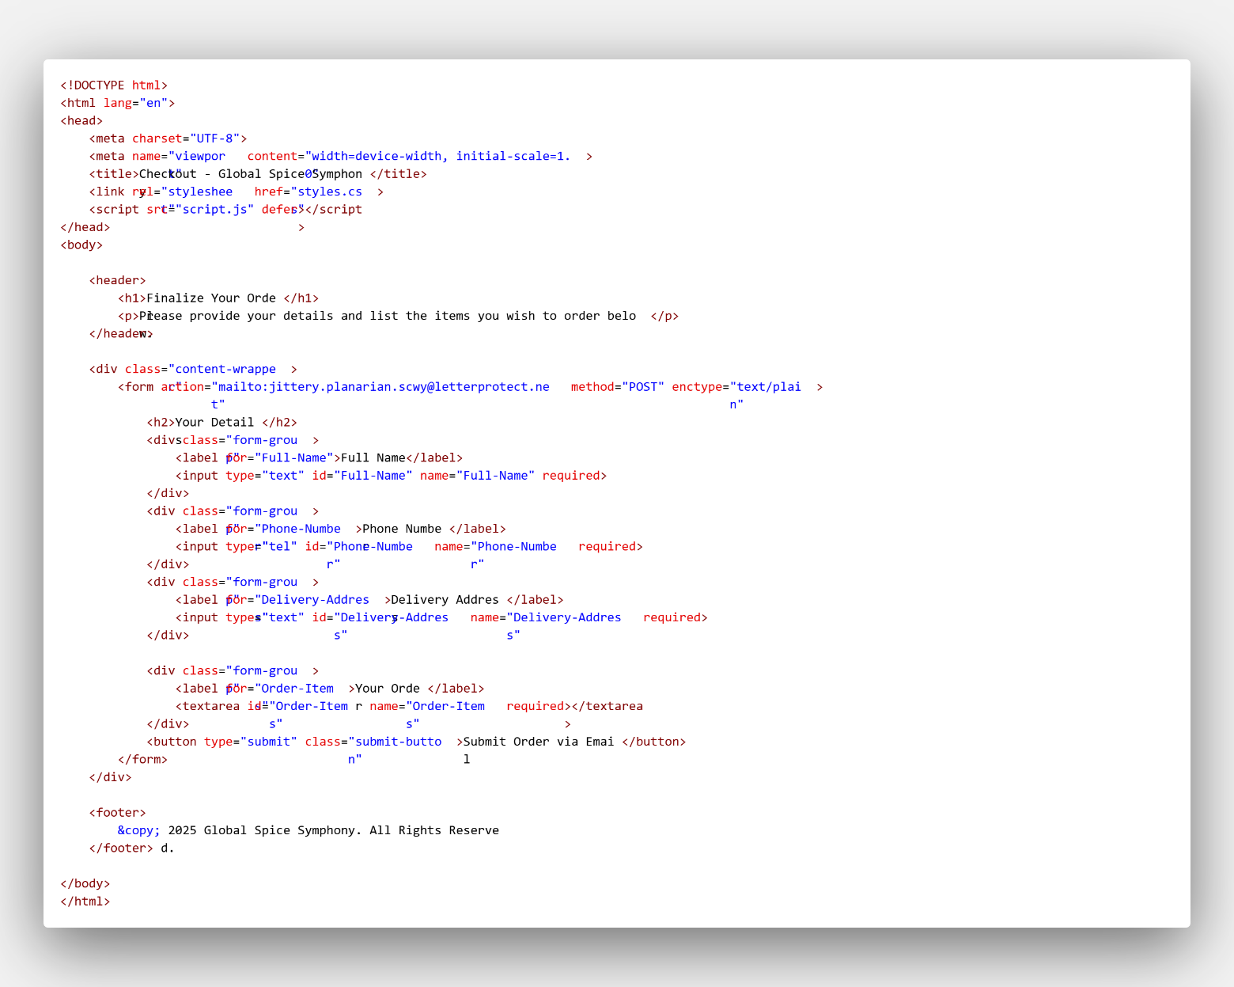

aboutus.html

contactus.html

style.css

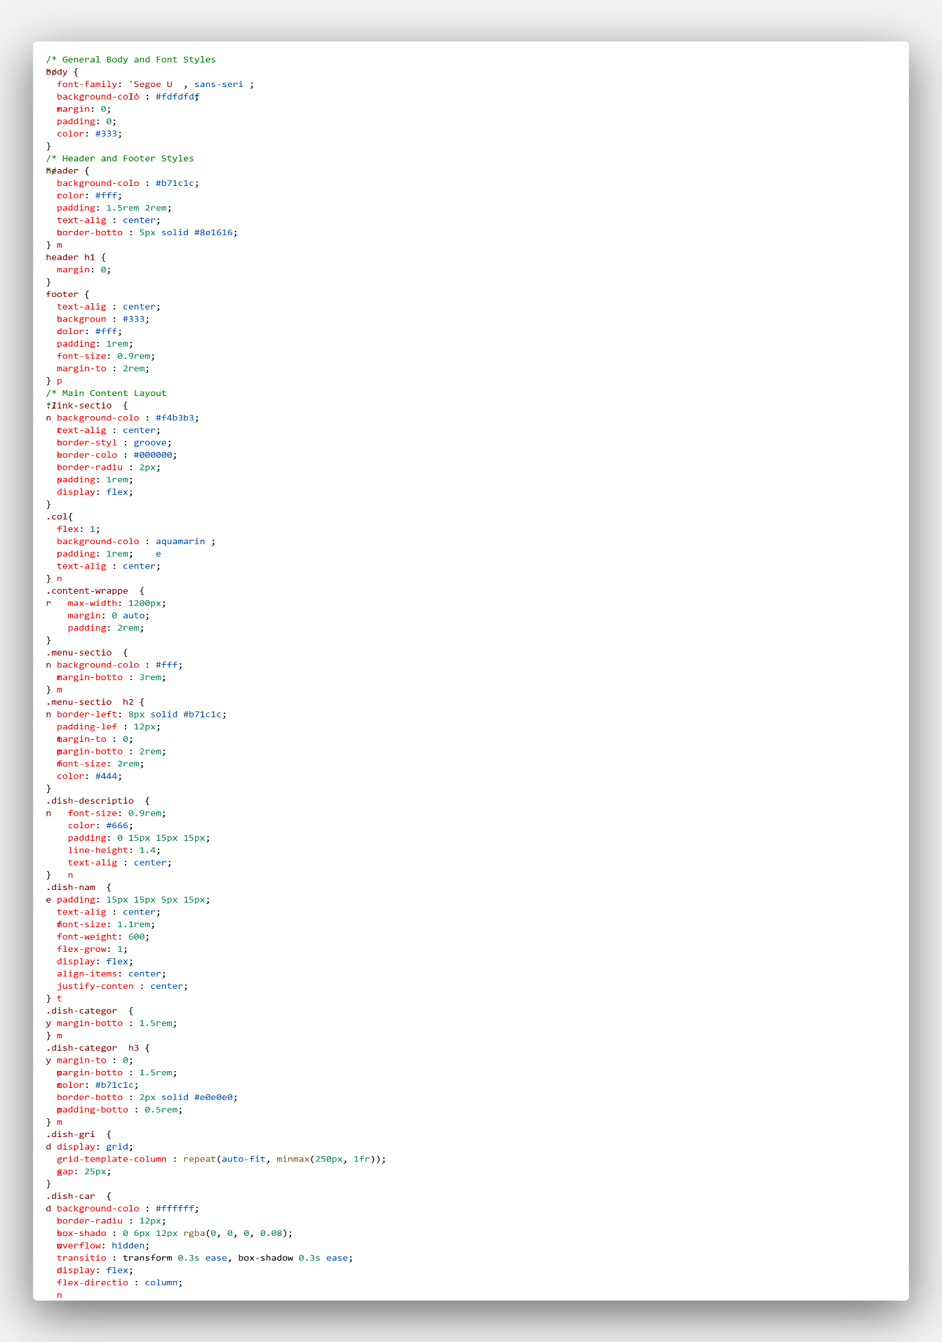

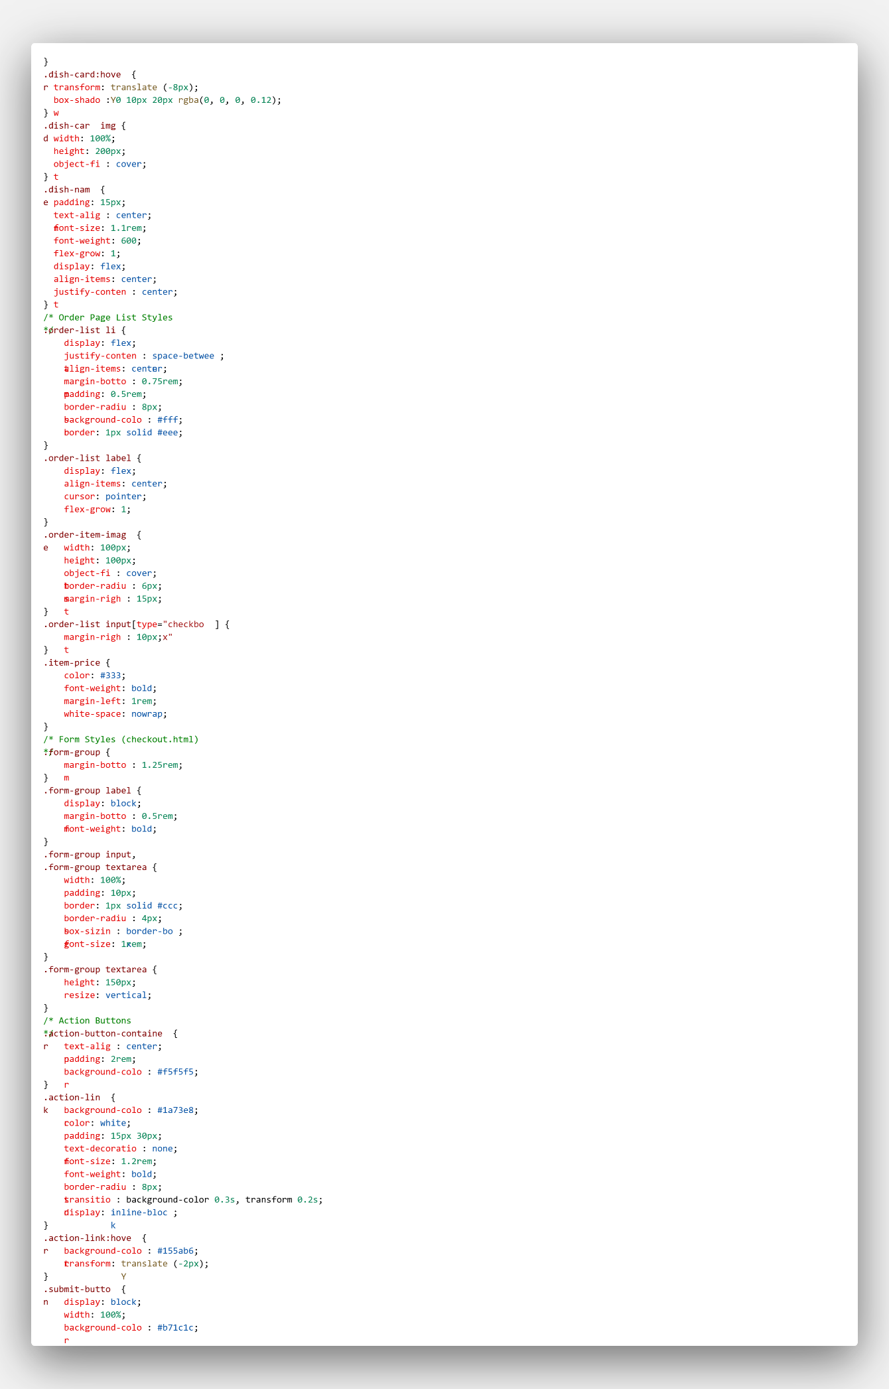

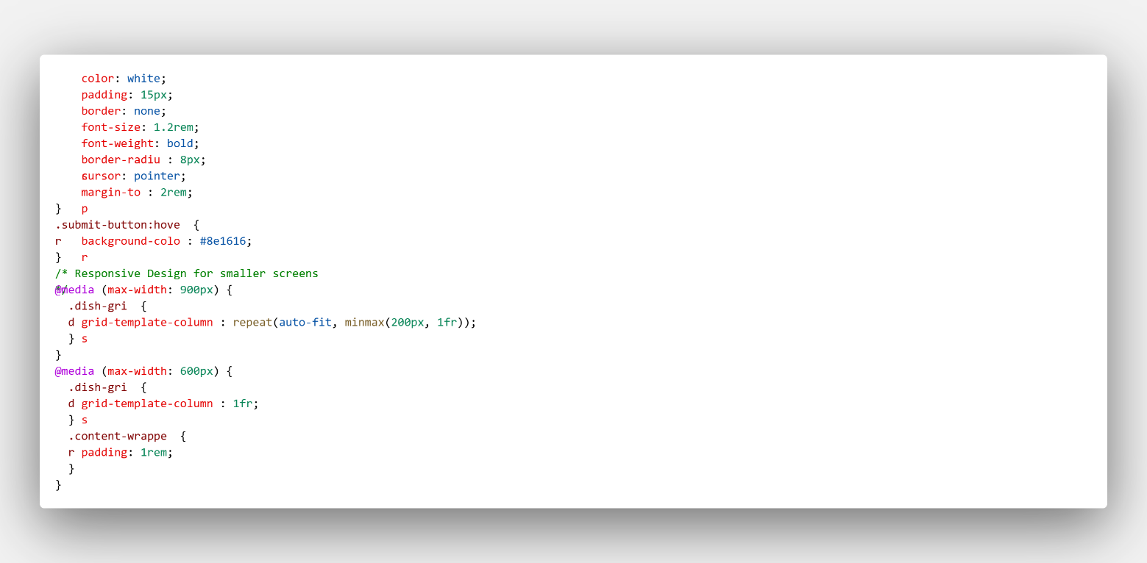

script.js

